积分网站需求文档（毛子）

Points game platform requirements description

平台简介：这是一个积分游戏网站，用户通过客服或者其他第三方聊天工具，向房间管理员申请平台积分，房间管理员接到请求后会在后台管理系统手动为用户添加积分。用户获得初始积分后，就可以通过房间内的游戏进行下注操作来获取更多的积分或者输掉积分。房间管理员也有属于房间管理员的专属游戏平台。房间管理员只能通过第三方聊天工具向 admin 申请房间管理员的专属游戏平台的积分，然后通过平台的游戏进行下注用来赢取更多积分或者输掉积分

Platform introduction: This is a point game website. Users apply for platform points to the room administrator through customer service or other third-party chat tools. After receiving the request, the room administrator will manually add points to the user in the background management system. After the user obtains the initial points, they can bet through the game in the room to gain more points or lose points. Room administrators also have their own gaming platforms that belong to room administrators. The room administrator can only apply to the admin for points of the room administrator's exclusive game platform through a third-party chat tool, and then bet through the platform's games to win more points or lose points

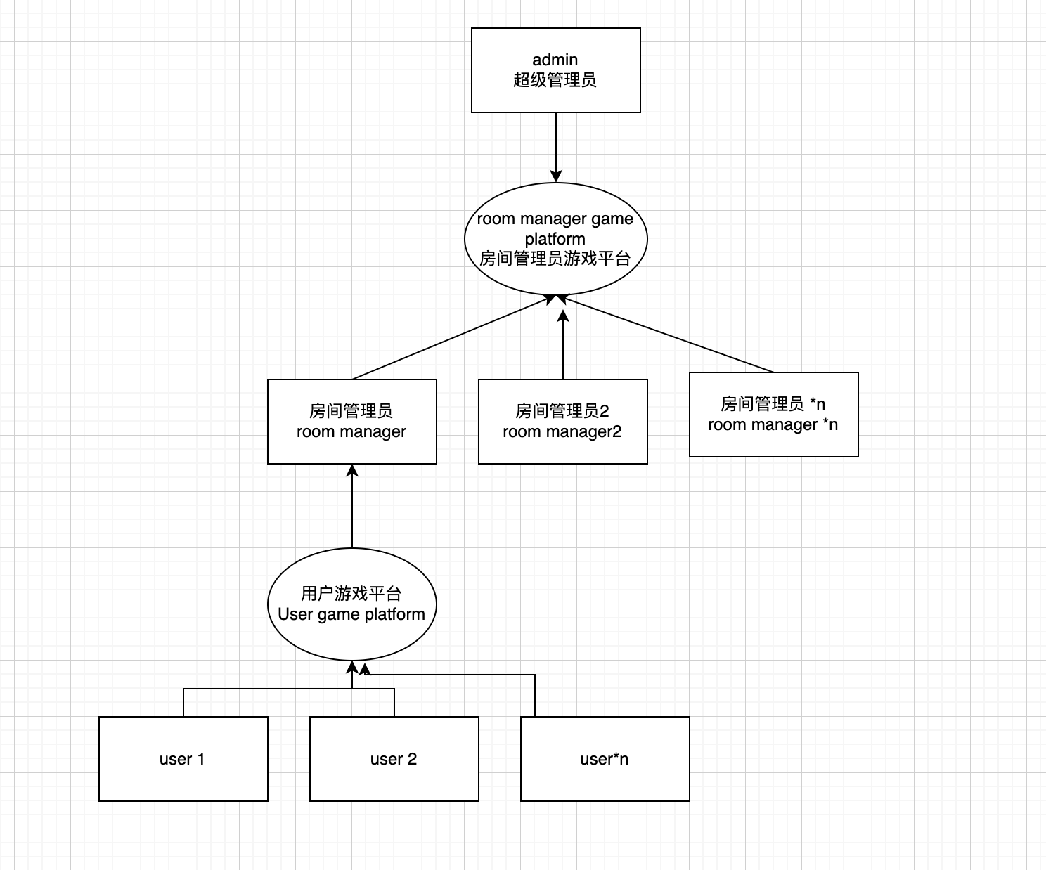

游戏房间的创建和删除只能由超级管理员进行操作。超级管理员开启的房间数量大概在300-500个以上。每个游戏房间内的用户数据都是独立的，且每个房间的游戏玩家同时在线数量不会超过100个。

The creation and deletion of game rooms can only be performed by super administrators. The number of rooms opened by the super administrator is probably more than 300-500. The user data in each game room is independent, and the number of gamers online in each room will not exceed 100 at the same time.

# 1、用户游戏平台说明（User game platform description）

The user enters the game platform through the mobile device to play the game. After logging in the website, the user needs to enter the corresponding room number to select a room. The user's information in each room number is independent. After entering the room, the user selects the game they want to play, and makes a bet in the game room to win or lose points. .  
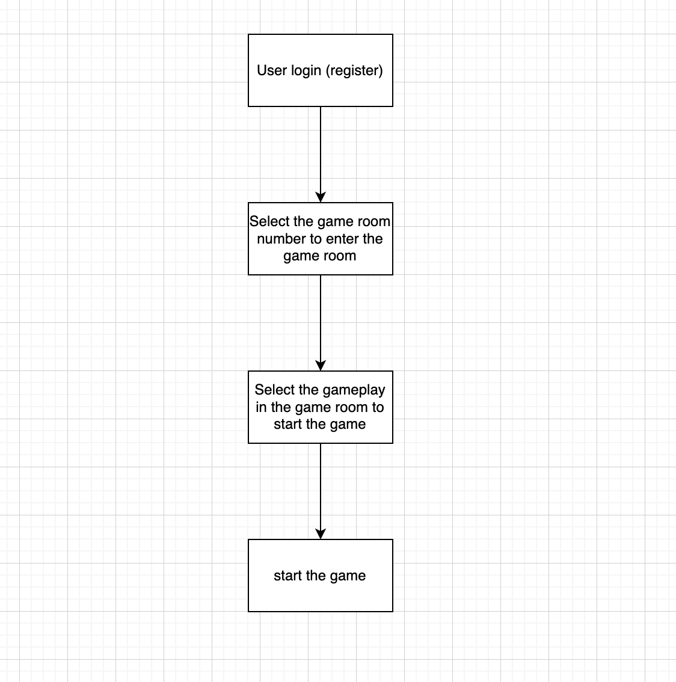

Process details

## 1、user login(register)

Users can use any combination of numbers and letters with more than 6 digits to register an account.

The registered information includes user login name and user password

Login after registration is complete

## 2、select the game room number to enter the game room

The room selection page consists of three parts

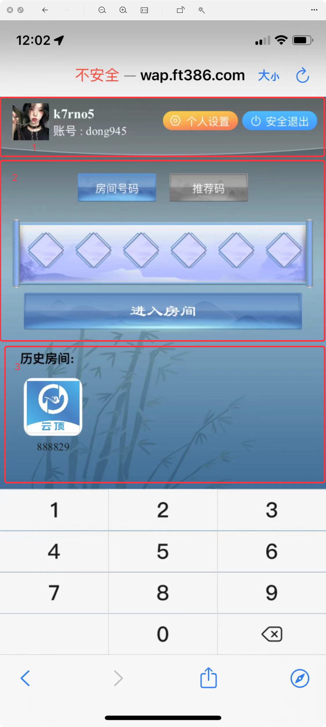 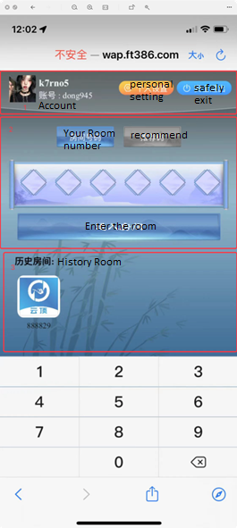

**1. Personal Information and Exit Button**

Here you can modify personal information including avatar, nickname and password. Exit button to return to the login page

**2. Room number input box part**

Here you can choose to enter the room number to enter the room, or you can choose to enter the recommendation code to enter the room. The first time you enter the room, you need to be reviewed by the administrator of the room before you can enter the room. After the review is passed, there is no restriction on entering the room.

**3. Room history**

Here is the previous room selection record, click here to quickly enter the room

## 3、Select the gameplay in the game room to start the game

The game lobby of the room consists of three parts

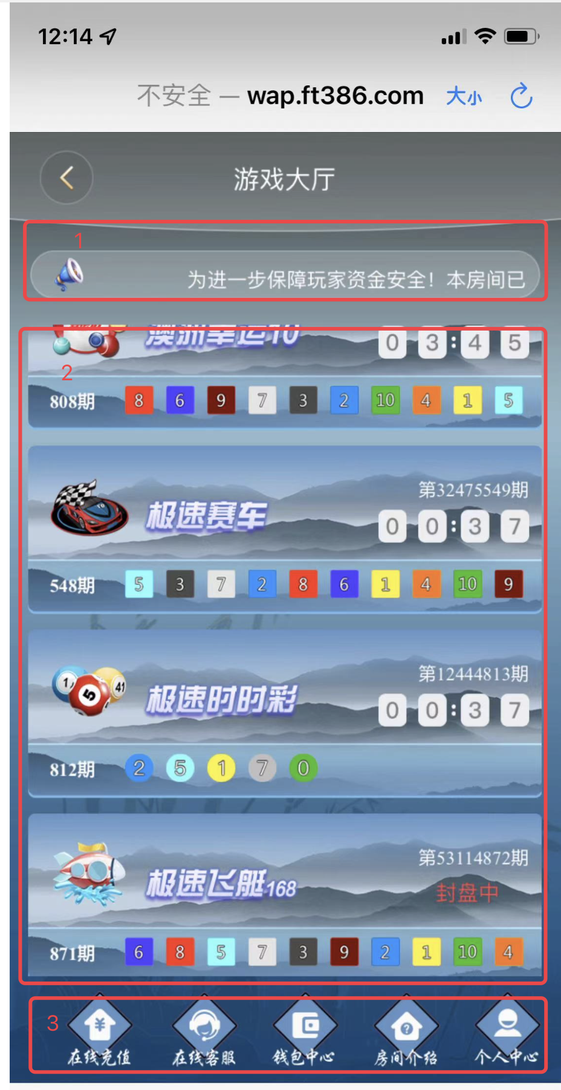 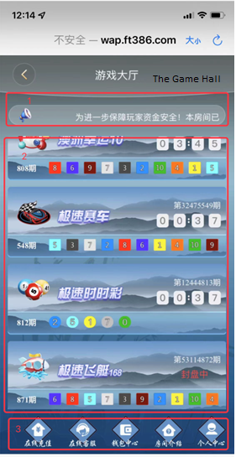

**1. Announcement**

The announcements displayed by the room manager will appear in a scrolling manner here.

**2. Game selection list**

Click the game in the game list to enter the game room to play the game, I will put the game list in the back and expand the description separately

Game List Each player's game list can be controlled in the background by the room admin. Players can request to change the list of games by sending a message through the customer service chat, and players themselves are not allowed to change

**3. Bottom operation button**

bottom button i only need 4 functions

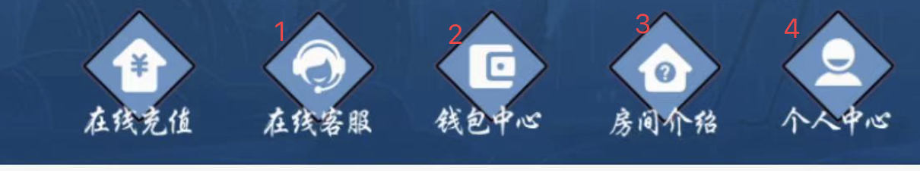

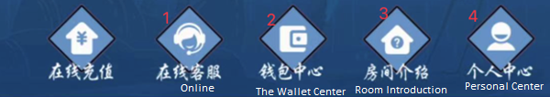

3.1 Online customer service

Through this button to enter the customer service chat interface, I can communicate with the customer service, and the chat interface supports sending and receiving pictures.

3.2 Wallet Center

The wallet center consists of two parts

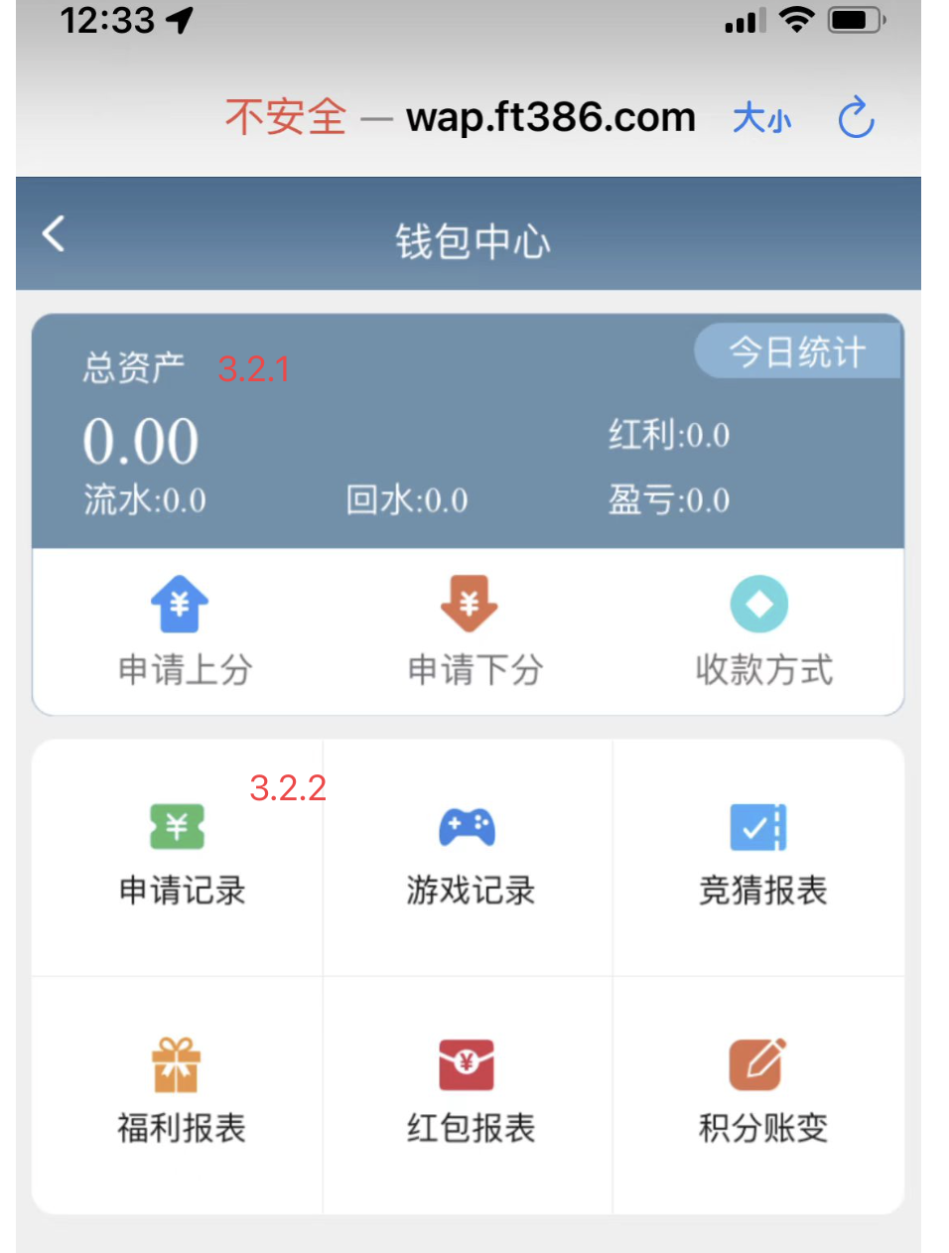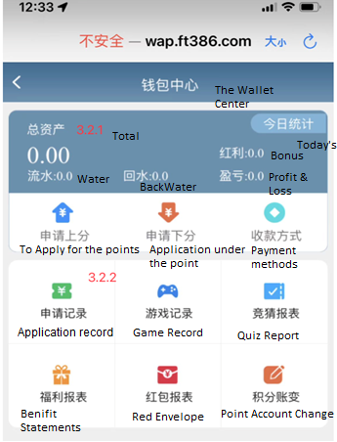

3.2.1 Integral Dashboard

The content of the integral dashboard is today's integral change statistics show that it includes the following contents

Total Assets: Existing total points

Points flow: the accumulated game betting points statistics of the day

Backwater: When the point flow reaches the flow standard set by the room administrator, the administrator will give back the points to the user according to a certain percentage

Bonus: When the recharge points reach the marking standard set by the room administrator, the administrator will give back to the user points according to a certain percentage

Profit and loss: The total profit and loss of the game today

3.2.2 Points record

The query time of all records in this section is controlled by the room administrator in the background. The record date that can be queried is two days by default.

3.2.2.1 Application record

Here is the interface for the customer service to manually recharge my points in the management background

3.2.2.2 Game Record

Here is my record of playing the game in the game room

3.2.2.3 Guessing report

The report of my participation in the game quiz

3.2.2.4 Benefit Statement

A report of the room manager giving me back points based on activities

3.2.2.5 Red Packet Report

Record of room administrators giving back points based on activities

3.2.2.6 Points account change

All my points change

3.3 Room introduction

The room introduction is divided into two parts, which are the description of the room introduction, and the description of the game rules in the game list. Switching between different games will display the description of the game rules corresponding to the game.

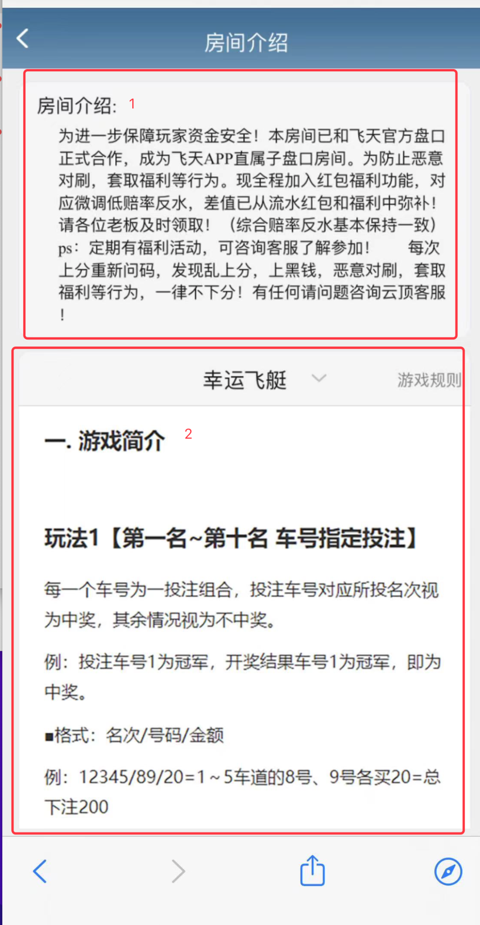

3.4 Personal Center

In the personal center, you can change the player's personal information, including changing the avatar, changing the password, and another function in the personal center is to control the switch of the background music and the size of the sound effect and background music.

## 游戏玩法介绍

这里举例一个玩法的介绍，其他游戏的玩法都类似只不过是游戏的规则不一样

这里我就举例第一个游戏『幸运飞艇』的玩法

在游戏列表里面点击「幸运飞艇」后进来的界面是这样的它分为三个部分

**There are about 10 ways to play the game**

**Here is an example of a gameplay introduction. The gameplay of other games is similar, but the rules of the game are different.**

**Here I will give an example of the gameplay of the first game "Lucky Airship"**

**After clicking "Lucky Airship" in the game list, the interface that comes in is like this. It is divided into three parts**

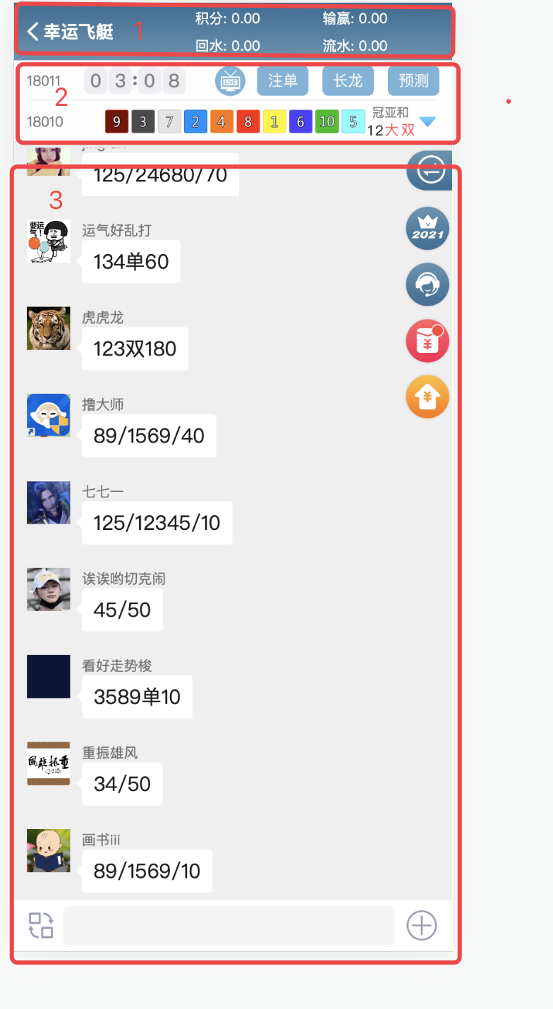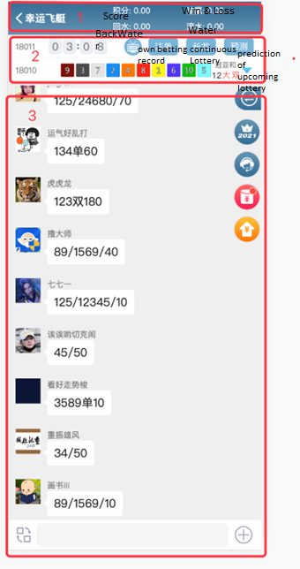

1. Top

In addition to returning to the game selection page, the user's wallet information can also be displayed here.

2. Lottery Dashboard

The lottery dashboard is divided into two lines. The information displayed on the first line is the lottery countdown, lottery animation, own betting records, continuous lottery records and predictions for the upcoming lottery.

The second line shows the historical lottery content. Click the select drop-down button to see the lottery records of different games.

**3. User betting area**

All users in this game room can place bets through user input instructions, and the user input instructions include the user's betting method and points for this game. After each bet is completed, the system automatically calculates whether the user wins or loses.

Instructions are described below

let's go into the room introduction choose the game we're playing right now「幸运飞艇」View Game Instructions

Beijing time (GMT+8) is open every day from 08:00:15 am to 07:55:15 am the next day, every five minutes, with 288 sessions per day. Note: The time of the last issue of each day is from 07:55:15 in the morning to the opening 08:00:15 the next day.

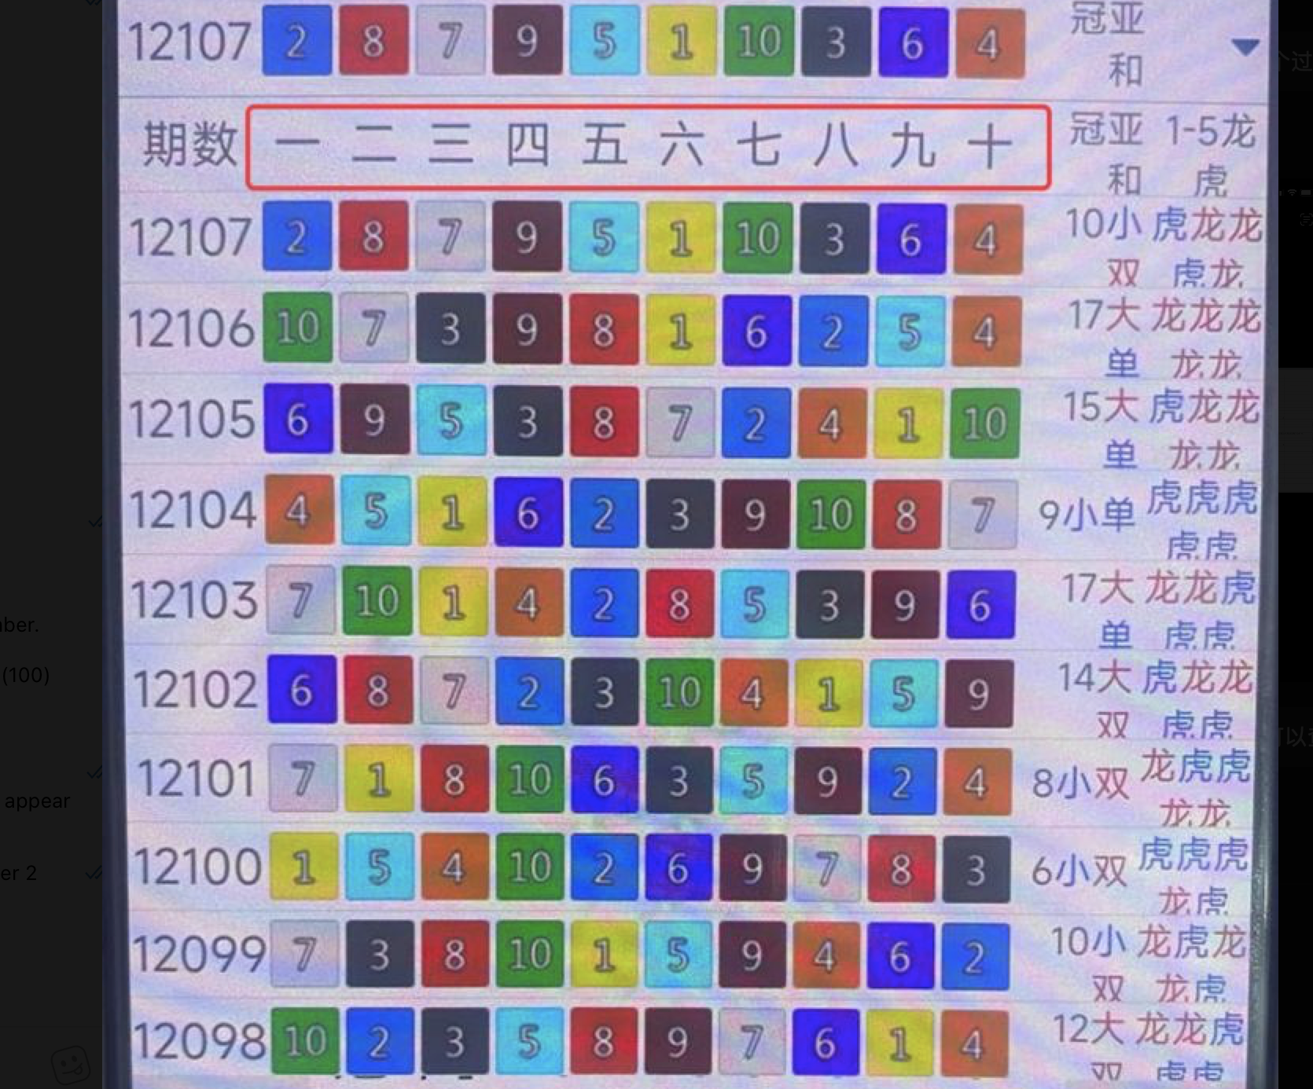

---- nper 

The lottery of each issue is ranked according to the numerical order

**play 1** [1st place ~ 10th place car number designated bet]

Each car number is a betting combination, the betting car number corresponding to the voted ranking is regarded as winning, and the rest is regarded as not winning.

For example: the betting car number 1 is the champion, and the lottery result car number 1 is the champion, that is, the winning.

Command format: Lane/driver/amount

E.g：12345/89/20= Buy 20 for 8 lane numbers and 9 numbers from 1 to 5 = total bet 200

E.g：1357/890/20=1.3.5.7 8th, 9th, and 10th of the lane buy 20 each = total bet 240

**play 2** [1st place ~ 10th place double-sided betting]

Refers to the single and double size from the champion to the tenth place

单(single)、双（double）：If the number is a singular number, such as: 1, 3, 5, 7, 9, number

If the code is an even number, it is called double, such as: 2, 4, 6, 8, 10. Bet on car number pair

The single and double votes shall be regarded as winning, otherwise it shall be regarded as not winning.

For example: betting on the champion position is double, and the winning position in the lottery result is car number 2.

winning.

大（big）、小（Small）：The number drawn is greater than or equal to 6, and the number is less than or equal to 5.

Small. The betting car number corresponding to the size of the bet is regarded as winning, otherwise it is regarded as not winning

prize.

For example: the betting champion is big, and the result of the lottery draw is the car number 6.winning.

Instruction format: ranking/size odd and even/amount

E.G：12345双100=1~5 lanes buy double 100 each = total bet 500

**Play 3**【1~5龙 ( Dragon) 虎 (Tiger) 投注】1~5 Dragon Tiger Betting

Champion Dragon/Tiger: The "1st place" car number is greater than the "10th place" car number

Winning the lottery for [Dragon], otherwise less than it is regarded as winning the lottery for [Tiger].

Runner-up Dragon/Tiger: The "second place" car number is greater than the "ninth place" car number depending on the

Winning the lottery for [Dragon], otherwise less than it is regarded as winning the lottery for [Tiger].

Third place Dragon/Tiger: The "third place" car number is greater than the "eighth place" car number

It is regarded as [Dragon] winning, otherwise less than [Tiger] winning.

Fourth place Dragon/Tiger: The "fourth place" car number is greater than the "seventh place" car number

It is regarded as [Dragon] winning, otherwise less than [Tiger] winning.

Fifth place Dragon/Tiger: The "fifth place" car number is greater than the "sixth place" car number

It is regarded as [Dragon] winning, otherwise less than [Tiger] winning.

Instruction format：Rank/Number/Amount

E.G：123 龙 100 = 1~3 lanes to buy dragons 100 each = total bet 300

**play 4**【冠军车号＋亚军车号=冠亚和值】 [Champion car number + runner-up car number = crown and Asia sum value] ()

Champions and singles and doubles: "Single" is regarded as a single bet "single"

A single bet is regarded as winning, and a double bet is regarded as betting "double" bet single is regarded as winning,

The rest will be deemed not to win.

Champions and Bigs: "Big" bets when the "Heavy Value" is greater than 11

A single bet is regarded as winning, and a bet of "Small" when it is less than or equal to 11 is regarded as a single bet

Win the lottery, the rest will be regarded as not winning.

Instruction format: crown Asia sum/size odd and even/amount

例：冠亚和双100=「冠亚和」的双100 （Guanya and Double 100 = Double 100 of "Cuanyahe"）

Crown Asia and Designation: The possible results of " crown Asia sum value" are 3-19. Those who hit the numbers corresponding to " crown Asia sum value" are regarded as winning, and the rest are regarded as not winning.

Instruction format：Crown Asia sum/number/amount

E.G：冠亚和567/100=竞猜「冠亚和」的值为5或6或

7各100=总下注300（Guanyahe 567/100 = Guess the value of "Cuanyahe" is 5 or 6 or

7 each 100 = total bet 300

）

【Guess Description】

No ranking, default quiz first place，如「双/100」first double

100.

There may be a 1-2 second delay during the guessing due to the variable network quality in different places.

The system determines whether the quiz is successful or not.

- Cut the result) The quiz record shall prevail. If the point is deducted, there will be a quiz record at the end

record, please contact customer service for processing, no matter whether you win or not, the remaining points will be refunded

deal with.

Now let's go back to the betting interface

see description of keyboard input

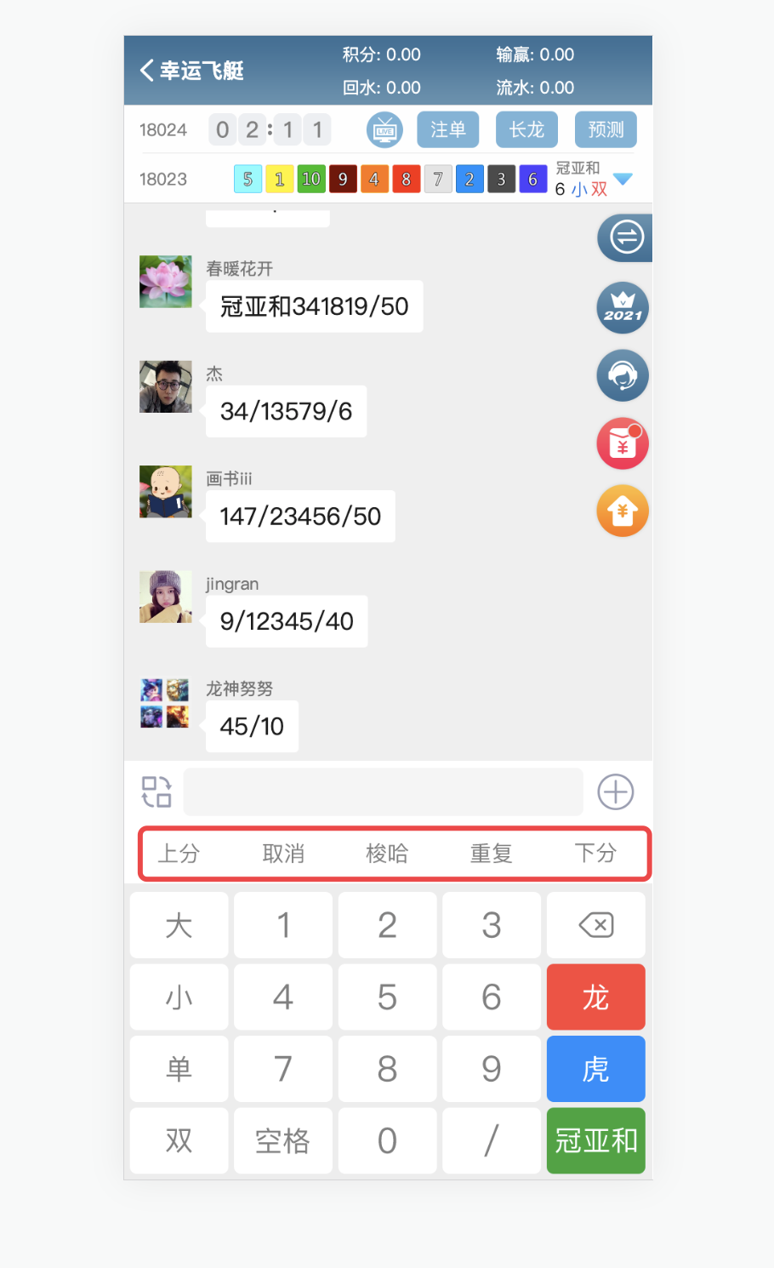

**上分：**Send this command to the chat system in the group, the chat system will capture this command and send it to the room administrator management background system, and the room administrator will recharge the user's points through the management background

取消：Send this command to the group chat system to cancel the previous betting command

**梭哈：**Send this command to the chat system in the group, the next bet will use all the remaining points of the user

**下分：**Send this command to the chat system in the group, the chat system will capture this command and send it to the room administrator management background system, and the room administrator will clear the points to the user through the management background

The other parts of the keyboard allow users to combine corresponding commands according to the game rules and send them. Any information outside the game rules is not allowed to be sent to the group chat system. The chat system will automatically place bets according to the instructions sent by the user. It is not allowed to send commands to the group chat system 10 seconds before the draw time. After the game is over, the chat system will automatically broadcast the user's winning information and automatically settle the user's betting result.

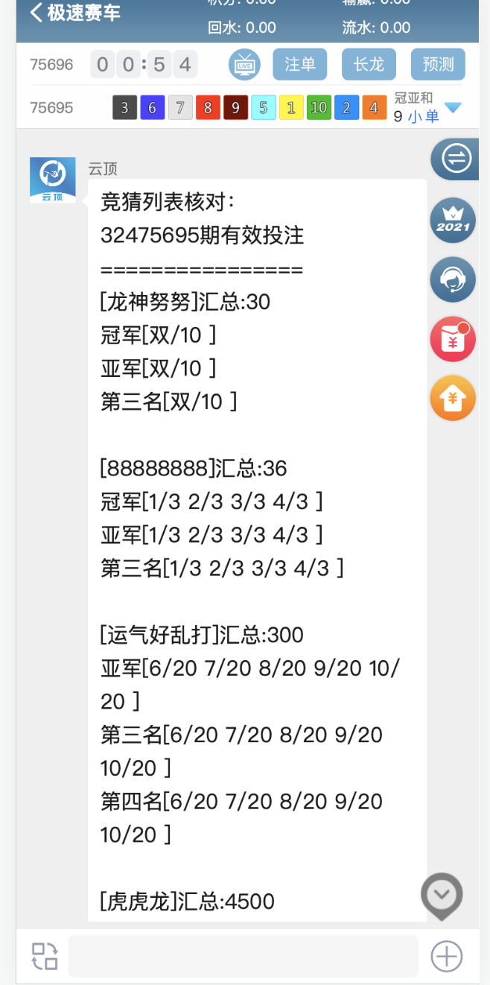

**Each game has its own lottery address. For example, the lottery address of the game you are playing now is this**

[**https://kjw.ig775.com/kaijiangweb/getLotteryInfo.do?issue=&lotCode=XYFTOLD**](https://kjw.ig775.com/kaijiangweb/getLotteryInfo.do?issue=&lotCode=XYFTOLD)

qi

Other Supplementary Instructions

The admin user can assign N different game room numbers to different room administrators for use. When assigning room numbers, the admin sets the room usage time and the room administrator's account password. The data that the user selects for each different room is independent. Room-to-room data is isolated from each other.

# 2、房间管理员游戏平台说明（Room manager game platform description）

房间管理员游戏平台不允许注册，只能由游戏房间的主账号，以及主账号后台管理系统内的直属账号和代理账号，进行登录,它只有PC端的界面，该平台的积分是由房间管理员通过第三方聊天工具跟超级管理员申请，由超级管理员手动在超级管理员的后台管理系统为该游戏房间管理员添加积分。游戏规则与用户游戏平台的游戏规则相同。该平台有两种下注模式，这两种模式不允许同时开启。

该平台的游戏赔率由超级管理员在后台设置

The room administrator game platform does not allow registration, only the main account of the game room, as well as the direct account and agent account in the main account background management system, can log in. It only has the interface of the PC side, and the points of the platform are determined by the room administrator. Apply with the super administrator through a third-party chat tool, and the super administrator will manually add points for the game room administrator in the super administrator's background management system. The game rules are the same as the game rules of the user's game platform. The platform has two betting modes, which are not allowed to be open at the same time.

The platform's game odds are set in the background by the super administrator

Reference website address：https://www.k195.vip/  
账号（userName）：fygj123

密码（passworld）：admin1234

## 模式1：直接下注

房间管理员在该平台选择游戏后直接手动输入分数进行下注。

Mode 1: Direct betting

The room administrator directly enters the score manually to bet after selecting the game on the platform.

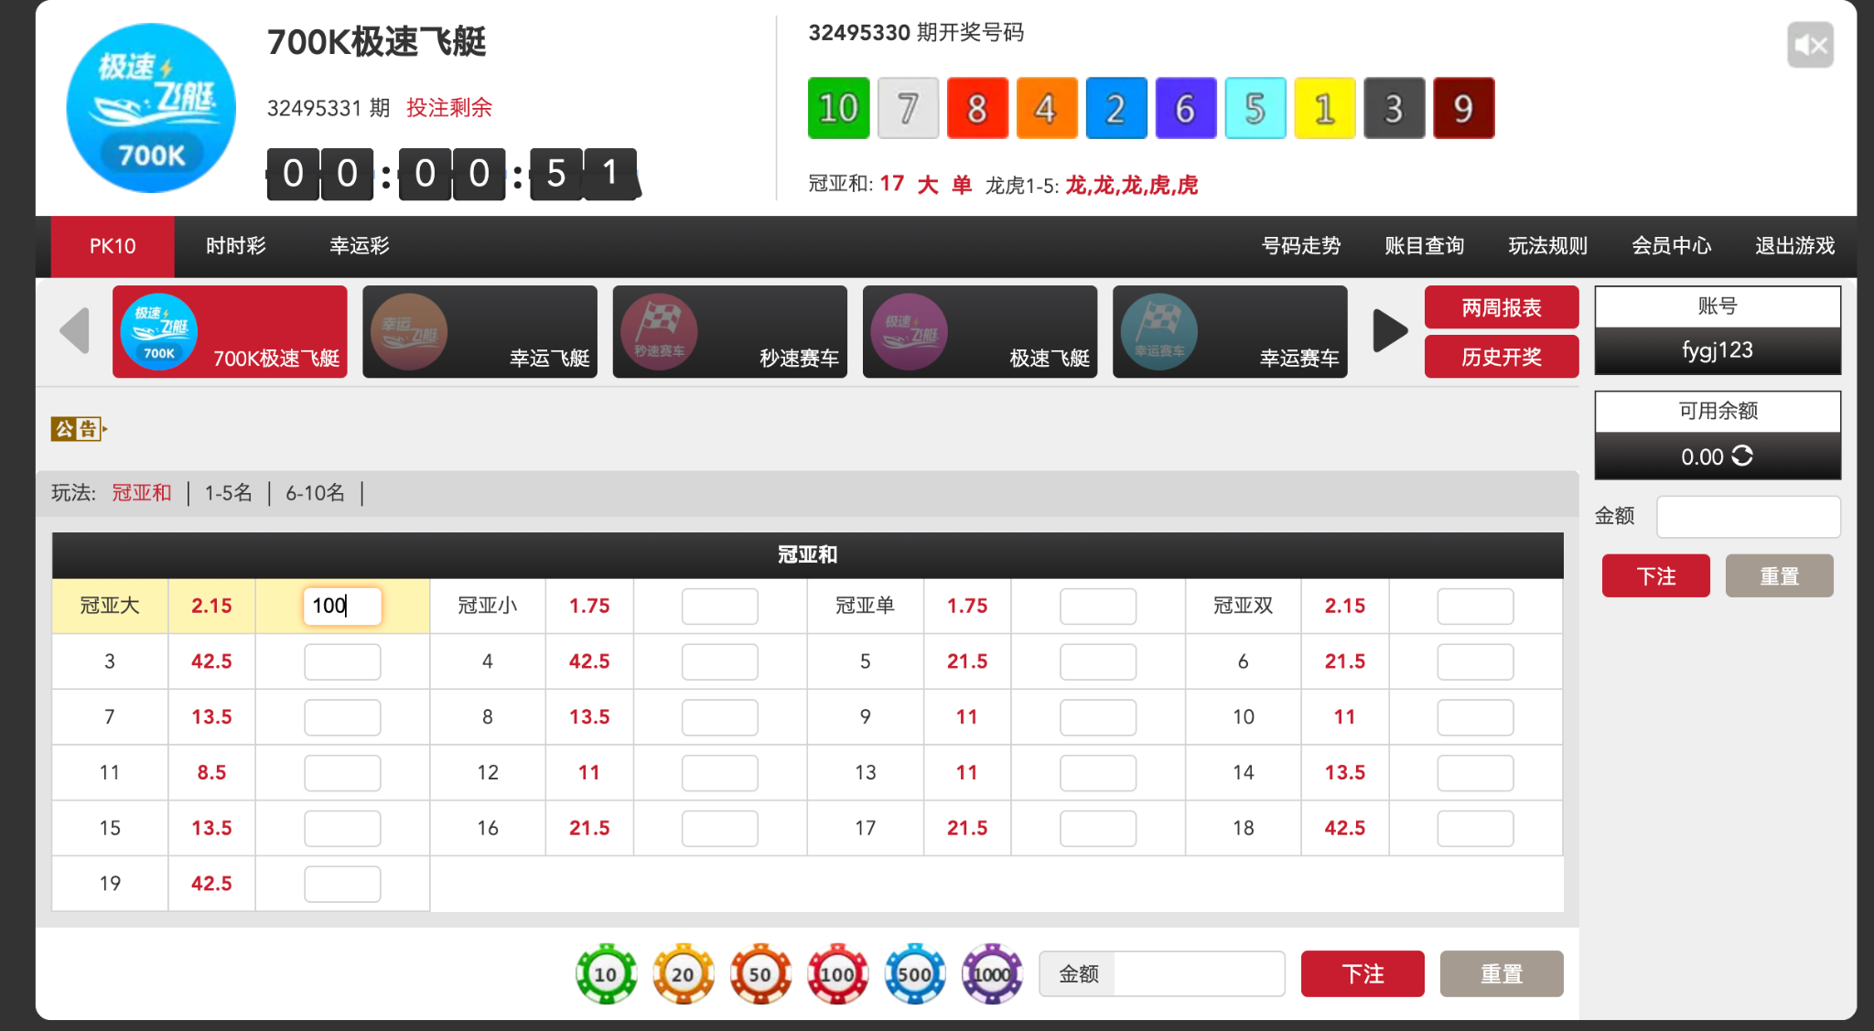

## 

## 模式2：复制游戏房间的下注订单到此平台进行下注

Mode 2: Copy the betting order in the game room to this platform for betting

房间管理员通过此地址的后台管理系统 <http://ft.zxkjwl.com/authority/login> 进行游戏订单复制操作

复制的模式有以下几种

1、全盘复制。自己所有游戏房间内的所有游戏的下注订单全部复制。

2、全盘按比例复制。自己所有游戏房间内的所有游戏的下注订单按百分比复制。

3、游戏房间复制。将游戏房间内的所有订单复制

4、游戏房间按比例复制。将游戏房间内的订单按比例复制

5、用户订单复制。复制某个用户的所有游戏订单

6、用户订单按比例复制。按比例复制某个用户的所有游戏订单

The room administrator can copy the game order through the background management system of this address <http://ft.zxkjwl.com/authority/login>

userName:fygj123  
pssworld:fygj123

The modes of replication are as follows

1. Full copy. All betting orders for all games in all of your game rooms are copied.

2. The entire disk is copied proportionally. The wagering orders for all games in all of your own game rooms are replicated as a percentage.

3. Copy the game room. Copy all orders in the game room

4. The game room is replicated proportionally. Proportional copy of orders in the game room

5. Copying of user orders. Copy all game orders of a user

6. User orders are copied proportionally. Proportional copy of all game orders for a user

这里我们把这种模式统称为：飞单

Here we collectively refer to this model as: feidan

这里解释一下为什么要复制下注订单到此平台进行下注，因为此平台的赔率是要比房间管理员开给用户的赔率是更高的，如果此平台开给房间管理员的赔率是 1：9.998 那么房间管理员开给用户的赔率就会低于这个赔率，可能是1：9.996 这时候房间管理员就可以在此平台挣这0.002的赔率。

Here is an explanation why you need to copy the betting order to this platform for betting, because the odds on this platform are higher than the odds offered by the room administrator to the user, if the odds offered by the platform to the room administrator are higher If it is 1:9.998, then the odds offered by the room administrator to the user will be lower than this odds, maybe 1:9.996. At this time, the room administrator can earn the odds of 0.002 on this platform.

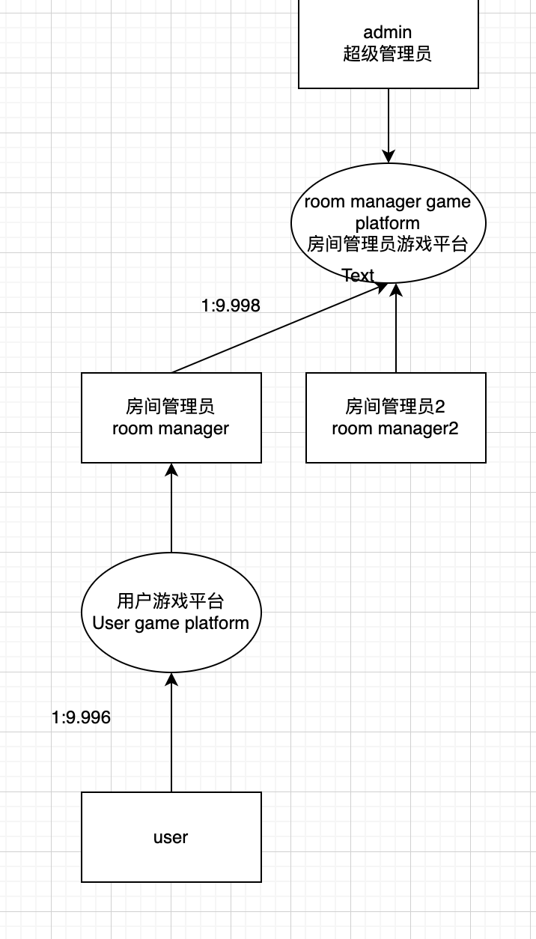

**第二种情况，游戏房间管理员是通过代理产生的**

In the second case, the game room administrator is generated through a proxy  
每一个房间管理员都可以发展自己的二级代理，二级代理又可以再次发展自己的代理。每一级代理的赔率都是上一级代理基于自己本身的赔率进行设定的

如果一级代代理降低了二级代理0.001的赔率 那么一级代理将享受二级代理所有订单转移流水*0.001的积分

二级代理发展下线同样如此

代理一共有9级

所有房间管理员的代理他们的房间号只能由超级管理员在后台进行添加

Each room manager can develop his own secondary agent, and the secondary agent can develop his own agent again. The odds of each level of agent are set by the superior agent based on their own odds

If the first-level agent reduces the odds of the second-level agent by 0.001, the first-level agent will enjoy the points of the second-level agent's transfer turnover of all orders*0.001

(feidan * 0.001)

The same is true for secondary agent development and offline

There are a total of 9 levels of agents

Agents of all room administrators and their room numbers can only be added by the super administrator in the background

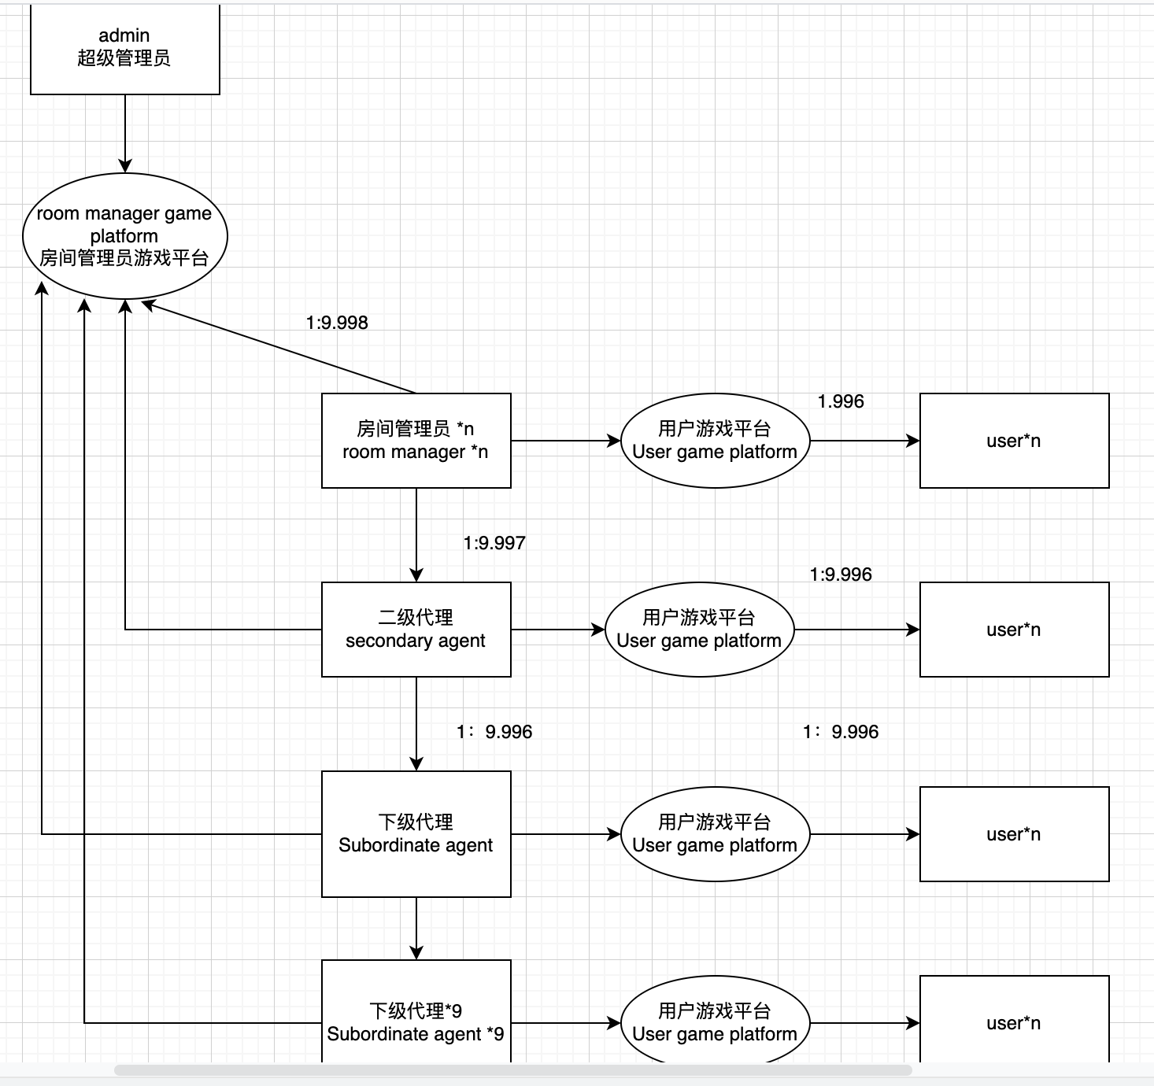

**也可以选择不减少赔率**

**You can also choose not to reduce the odds**

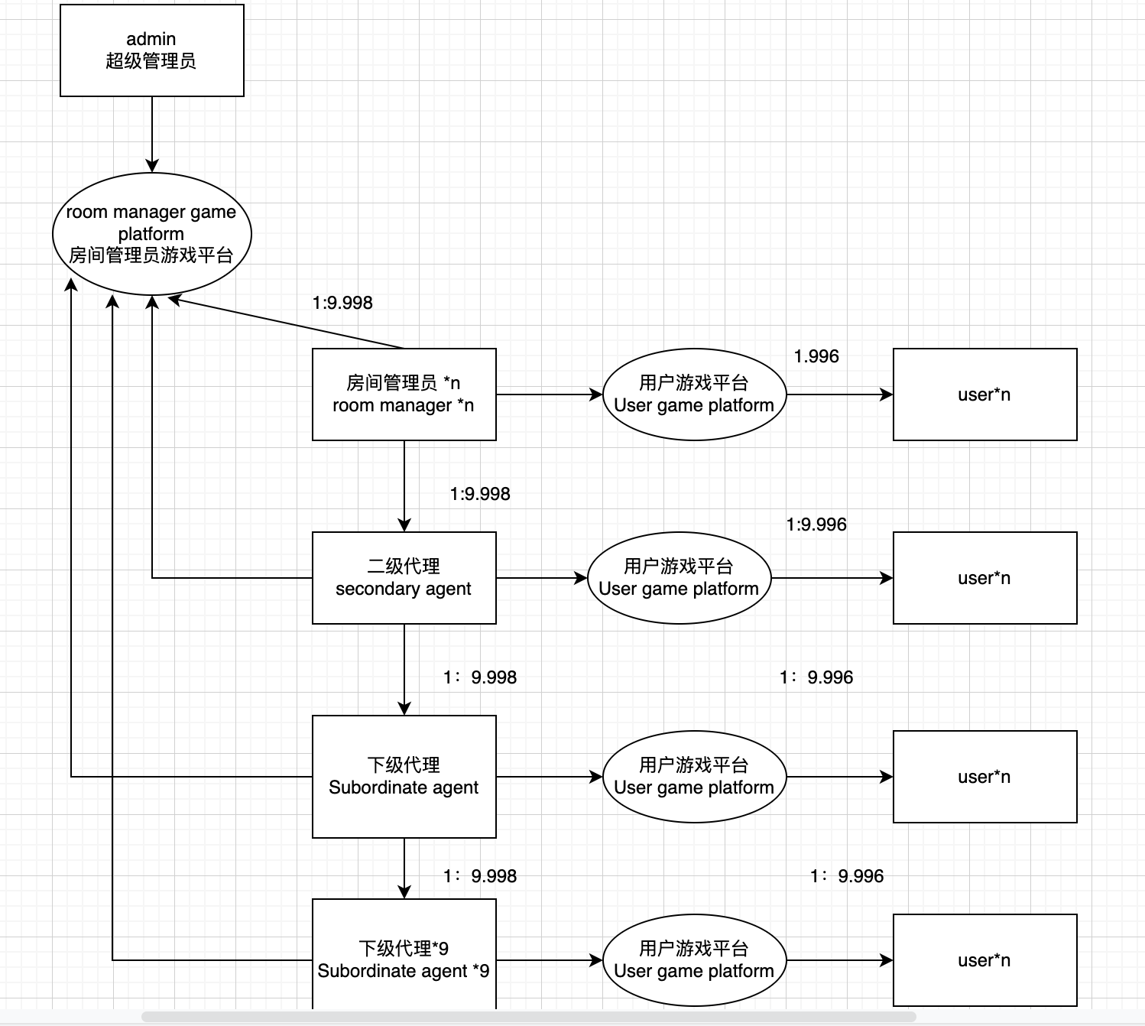

不减少赔率的情况下

由上级代理与超级管理员合力占股当前代理在房间管理员游戏平台的游戏积分输赢赔付。

例如：

二级代理当月订单(feidan) 在游戏管理员房间赢走10万积分的时候。由于一级代理与超级管理员有约定一级管理员占据二级管理员股份的30%，月底占股结算的时候，一级管理员需要支付3万积分给超级管理员。

二级代理当月订单（feidan)在游戏管理员房间输掉10万积分的时候。由于一级代理与超级管理员有约定一级管理员占据二级管理员股份的30%，月底占股结算的时候，超级管理员需要支付3万积分给一级代理

without reducing the odds

The superior agent and the super administrator will work together to share the current agent's game points on the room administrator's game platform. Win or lose compensation.

E.g:

When the second-level agent's order of the month (feidan) wins 100,000 points in the game administrator's room. Since the first-level agent and the super administrator have agreed that the first-level administrator will occupy 30% of the second-level administrator's shares, when the shareholding is settled at the end of the month, the first-level administrator needs to pay 30,000 points to the super administrator.

When the secondary agent's order of the month (feidan) loses 100,000 points in the game admin room. Since the first-level agent and the super administrator have agreed that the first-level administrator will occupy 30% of the second-level administrator's shares, when the shareholding is settled at the end of the month, the super administrator needs to pay 30,000 points to the first-level agent

一个游戏房间的股份可以被多个房间管理员与超级管理员共同持有。至于如何分配，则由管理员们自己沟通，然后由超级管理员在后台设定该群股份占比

Shares in a game room can be jointly held by multiple room managers and super managers. As for how to allocate, it is up to the administrators to communicate, and then the super administrator sets the proportion of the group's shares in the background

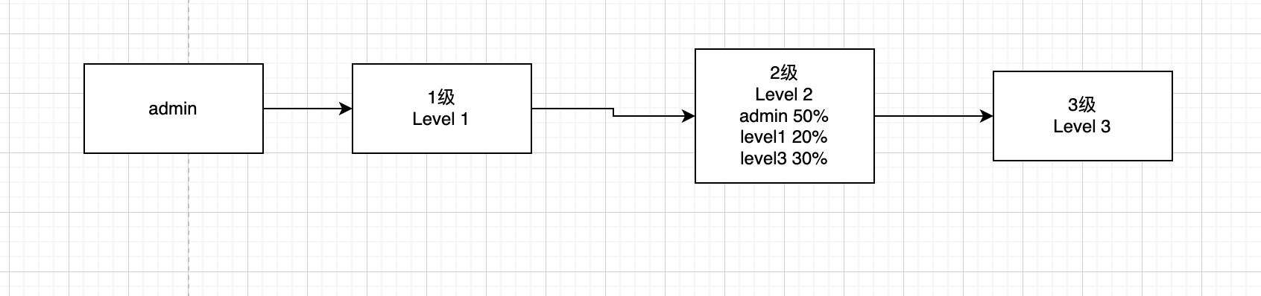

参考网站： 可以在此管理后台管理下级代理的各种信息

Reference website: You can manage various information of lower-level agents in this management background

<http://admin.k1zz.vip/ag/agent/query.html>

userName： gg08

passWorld: 112212